Practical 9

**Aim:**To understand how to use MongoDB

**About MangoDB:**

MongoDB is an open-source document database and leading NoSQL database. MongoDB is written in C++..

**use database_name:**



**createCollection()**



**insertOne():**

**Syntax:** db.collection_name.insertOne({record})

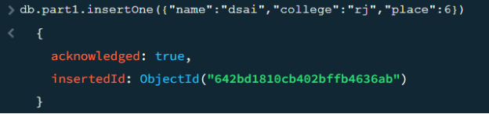

**insertMany():**

**Syntax:** db.collection_name.insertMany([{record},{record}])

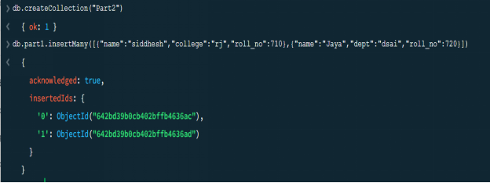

**find():**

**Syntax:** db.collection_name.find()

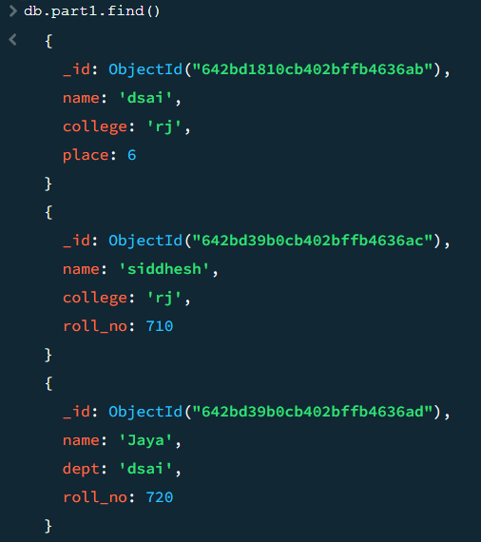

**Selection in find():**

You can select a single field in MongoDB using the following

**syntax:** db.yourCollectionName.find({"yourFieldName":yourValue});

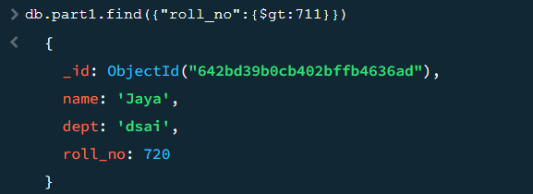

**Projection in find():**

**Syntax:** db.collection_name.find({},{"yourFieldName":1 or 0})

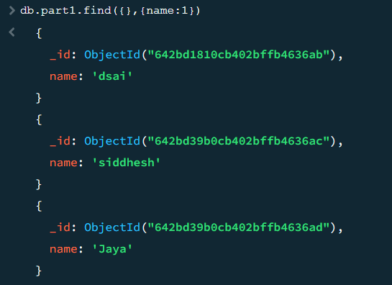

**Comparsion operation in find():**

|  |  |
| --- | --- |
| Name | Description |
| [$eq](https://www.mongodb.com/docs/manual/reference/operator/query/eq/#mongodb-query-op.-eq) | Matches values that are equal to a specified value. |
| [$gt](https://www.mongodb.com/docs/manual/reference/operator/query/gt/#mongodb-query-op.-gt) | Matches values that are greater than a specified value. |
| [$gte](https://www.mongodb.com/docs/manual/reference/operator/query/gte/#mongodb-query-op.-gte) | Matches values that are greater than or equal to a specified value. |
| [$in](https://www.mongodb.com/docs/manual/reference/operator/query/in/#mongodb-query-op.-in) | Matches any of the values specified in an array. |
| [$lt](https://www.mongodb.com/docs/manual/reference/operator/query/lt/#mongodb-query-op.-lt) | Matches values that are less than a specified value. |
| [$lte](https://www.mongodb.com/docs/manual/reference/operator/query/lte/#mongodb-query-op.-lte) | Matches values that are less than or equal to a specified value. |
| [$ne](https://www.mongodb.com/docs/manual/reference/operator/query/ne/#mongodb-query-op.-ne) | Matches all values that are not equal to a specified value. |
| [$nin](https://www.mongodb.com/docs/manual/reference/operator/query/nin/#mongodb-query-op.-nin) | Matches none of the values specified in an array. |

